REPORT ON

ICT LEARNATHON 2020

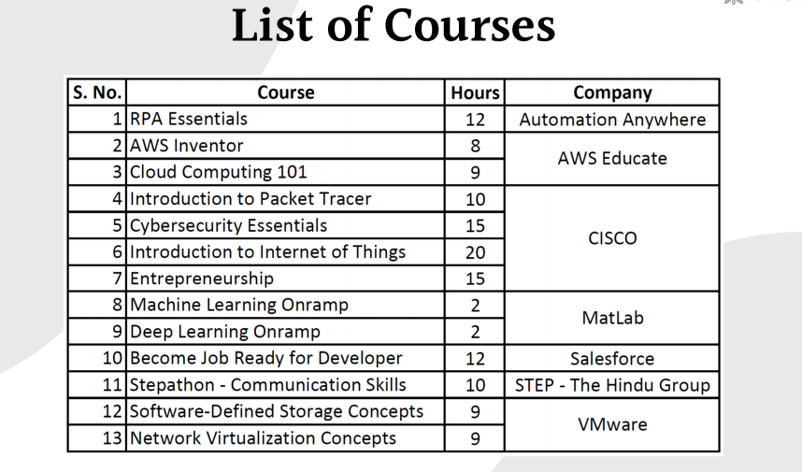

**1.RPA Automation**

RPA is for everyone. And the benefits of RPA span all industries and business units. Applying RPA for business process automation is limited only by the imagination and putting bots to work has never been easier, with a growing marketplace of ready-made, ready-to-deploy Digital Workers available on demand, requiring no specialized IT infrastructure.

Topics covered

1. Hello Bot: Introduction to RPA and Use Cases v11-3 hours

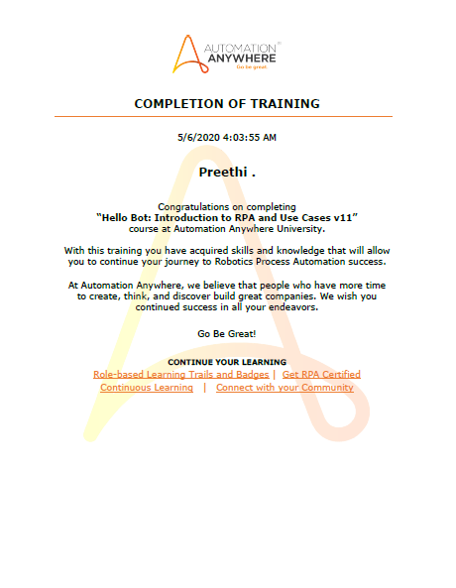

1. Build the digital work force -5 hours

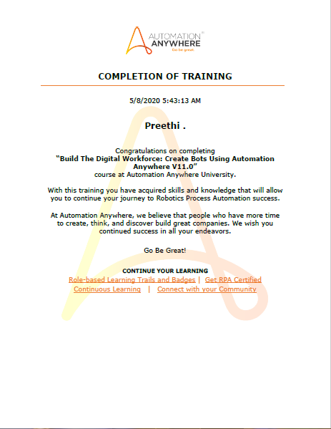

1. Storing and Manipulating Data: How to Automate Database-related Processes -30 mins

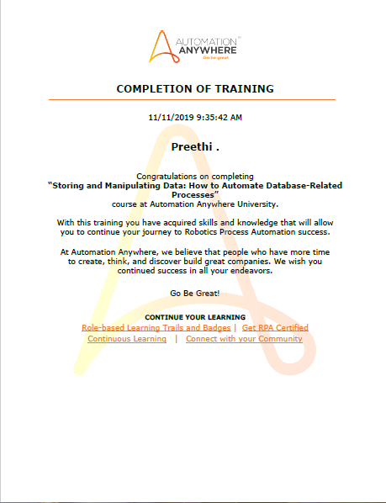

4.Automating Excel Operations: Methods to Work with Excel Workbooks -30 mins

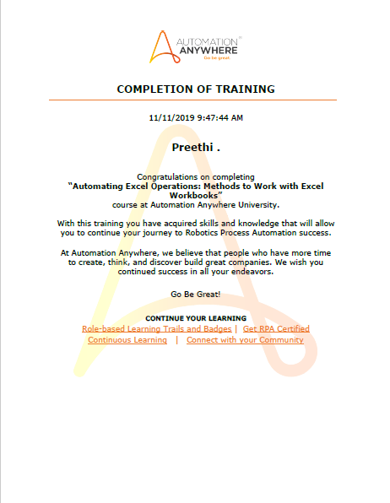

5.Working with PDF Documents: Methods to Automate PDF-Related Processes- 30 mins

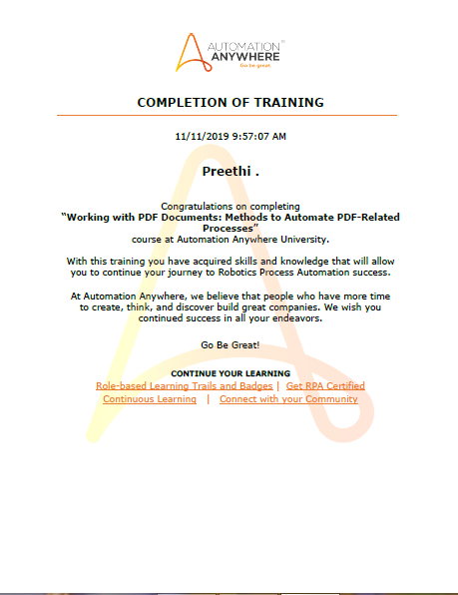

6.Automating Structured Data: How to Work with XML Streams- 30 mins

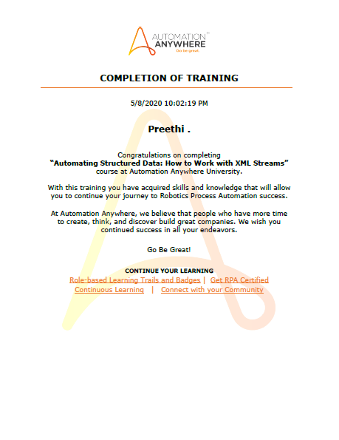

7.Automating String Operations: Methods to Manipulate and Extract Strings -30 mins

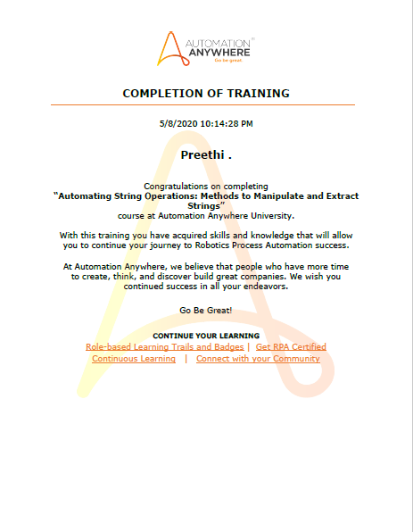

8.Communicating with Email Servers: Methods to Automate Email Messages- 30 mins

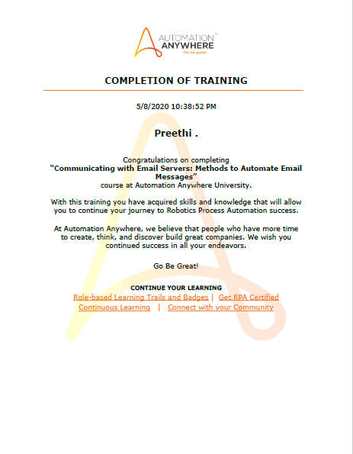

9.Communicating with Emulators: How to Automate Terminal Applications -30 mins

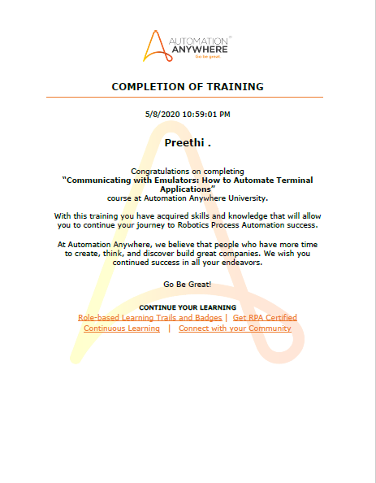

10 .Unleash Your Intelligent Bots: Developing Cognitive Bots, driven by AI & Machine Learning -30 mins

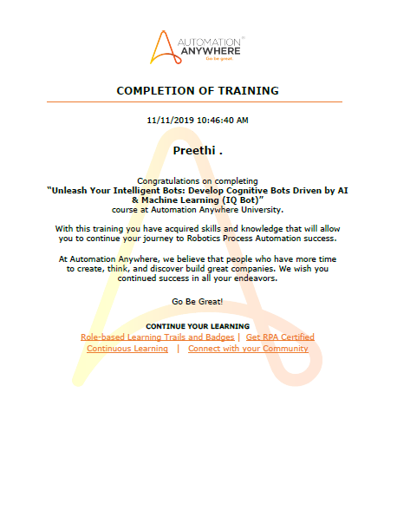

11.Bot Story: Where Automation Meets Analytics Using Bot Insight V11.0 2 hours Total Duration- 14 hours.

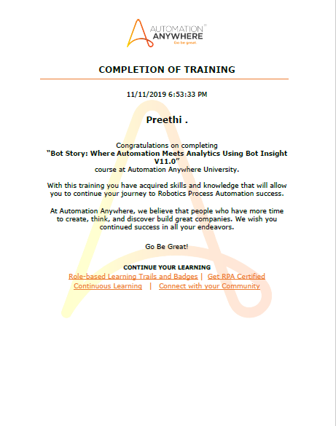

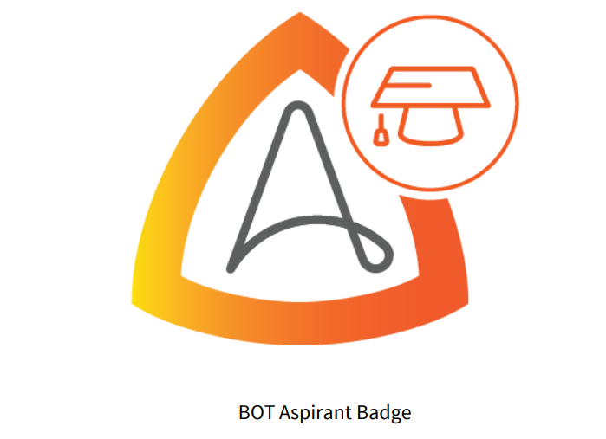

**2.AWS Educate**

The program is intended to induce self-learning and introduce basic cloud technology skills to all students. The program is organized exclusively for all institutions across India, where the students learn the modules online through self-instructed videos and exercises and prove their cloud learning skills. Start your journey on Cloud with AWS Educate.

Courses completed

1.Cloud Literacy – Inventor 8 hours

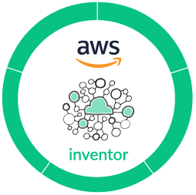

2. Cloud Computing 101 9 hours

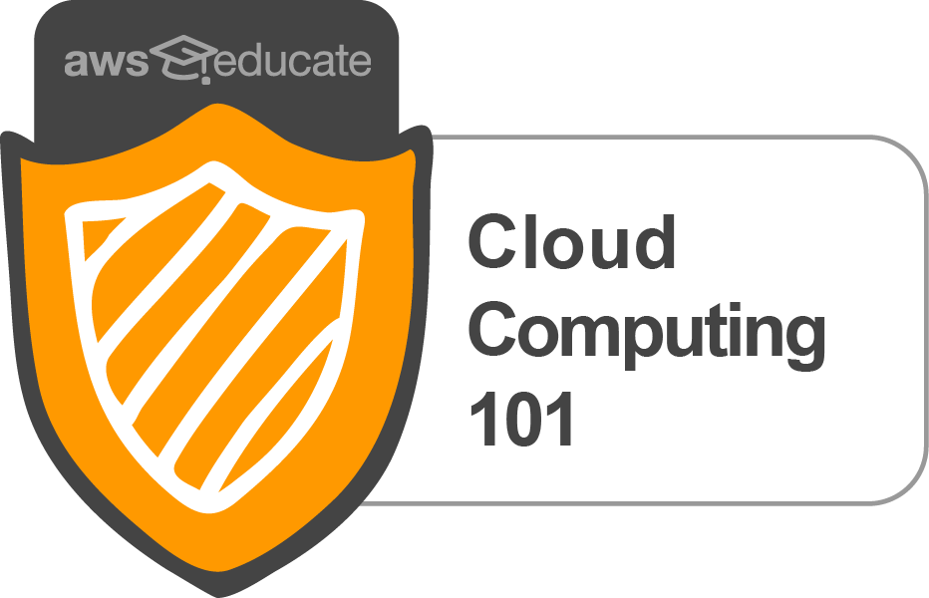

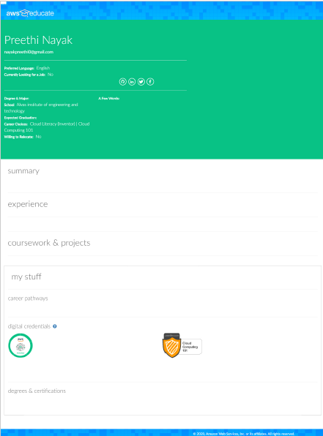

**3.CISCO Networking Academy**

Cisco Networking Academy is an IT skills and career building program for learning institutions and individuals worldwide. This platform helps you to practice what you learn, and become an IT professional. Here are few Beginner’s program, which gives the basic understanding of the respective course category.

Courses completed,

1. Introduction to Packet Tracer- 3 hours

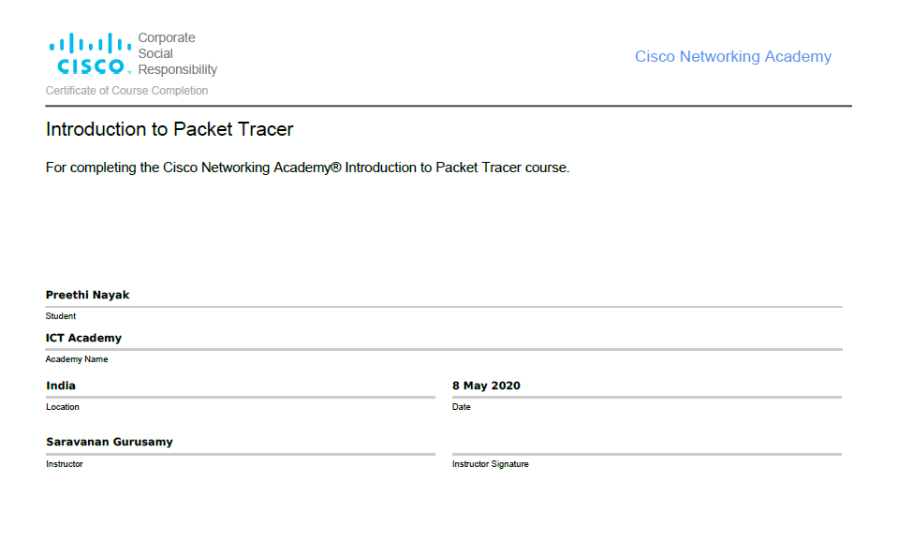

1. Cybersecurity Essentials- 5 hours

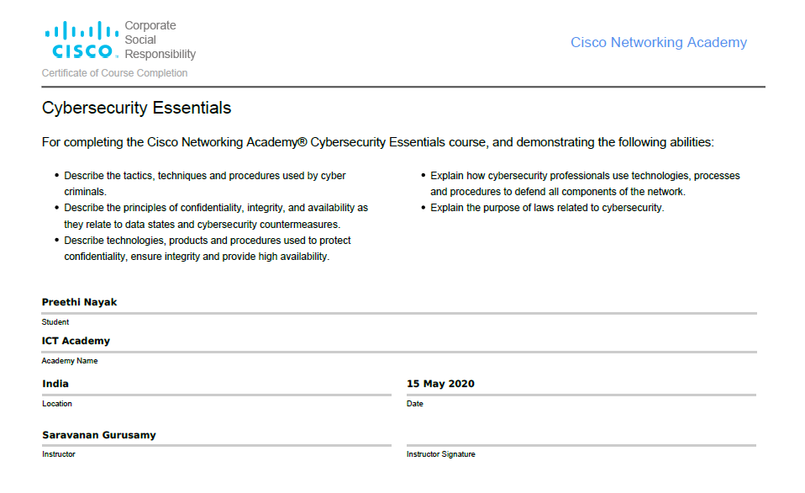

1. Introduction to Internet of Things -3 hours

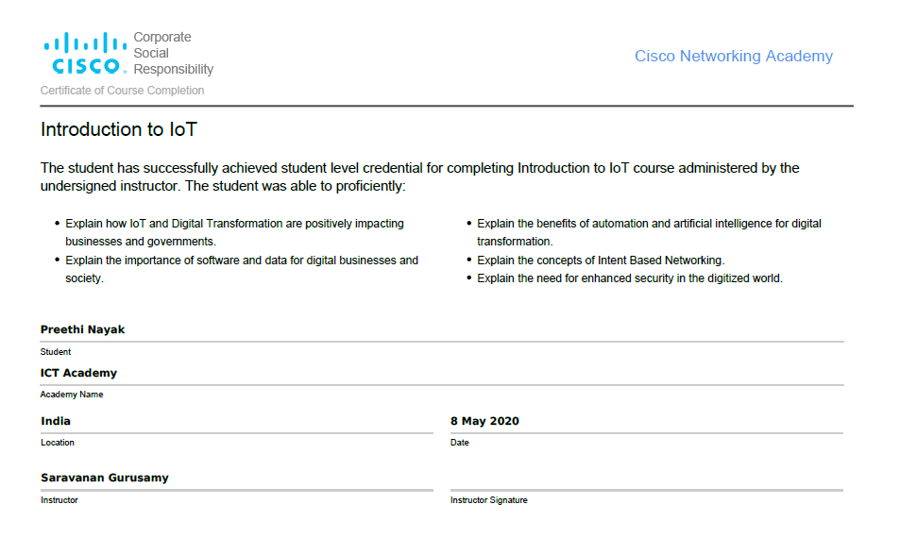

1. Entrepreneurship- 5 hours

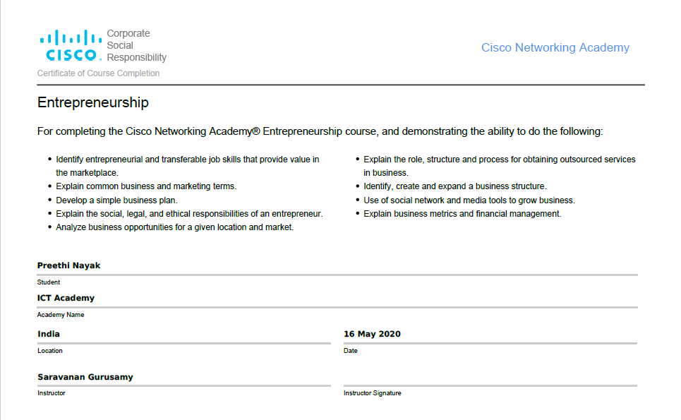

**4.MathWorks**

MATLAB offers this free course on Machine Learning and Deep Learning and provides an interactive introduction to practical methods on Deep Learning and Machine Learning. Here some of the topics that will be covered are classification workflows, importing and pre processing data and managing collections of image data. Advance your skills with MATLAB

1. Machine Learning Onramp- 2 hours

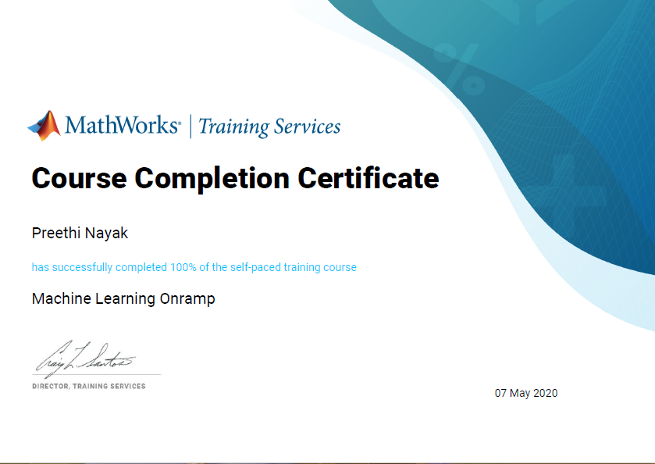

1. Deep Learning Onramp- 2 hours

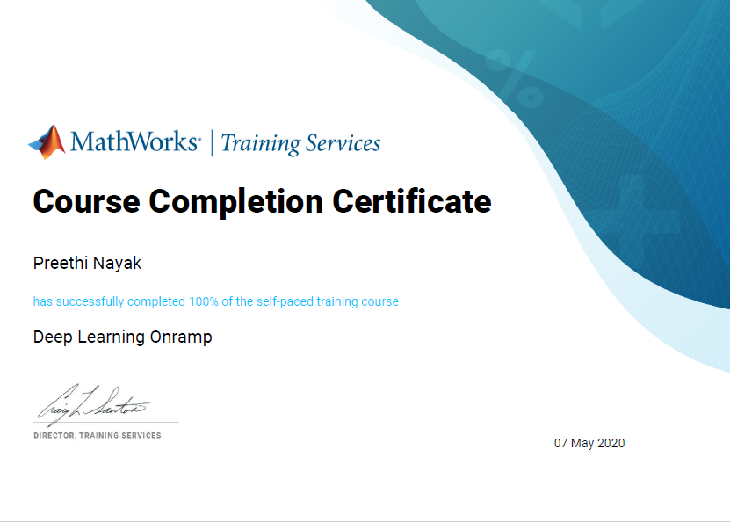

**5.Salesforce**

Salesforce Trailhead is a fun way to learn. Chances are, your next job will require Salesforce skills. This Trailmix is the initial step for the program "Become Job Ready for Developer"

Modules covered

1. Trailhead Basics -15 mins



2. Trailhead Playground Management -20 mins



3.Salesforce Platform Basics- 50 mins



4. CRM for Lightning Experience- 40 mins



5. Data Modeling- 45 mins



6. Build a Lemonade Stand App- 1 hour 30 mins



7. Picklist Administration -50 mins



8. Formulas & Validations -45 mins



9. Data Management- 40 mins



10. Reports & Dashboards for Lightning Experience- 1 hour 50 mins



11. Build a Data Model for a Recruiting App- 1 hour 5 mins



12. Create Reports and Dashboards for Sales and Marketing Managers- 1 hour 30 mins



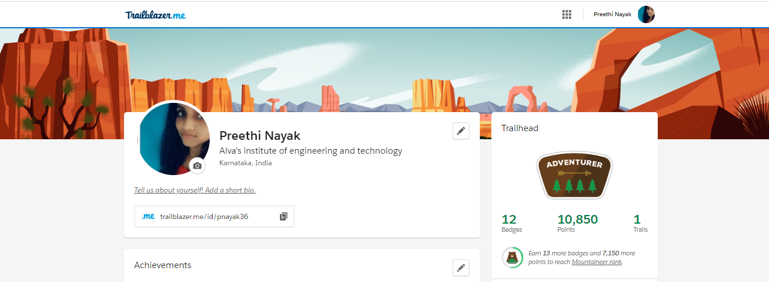

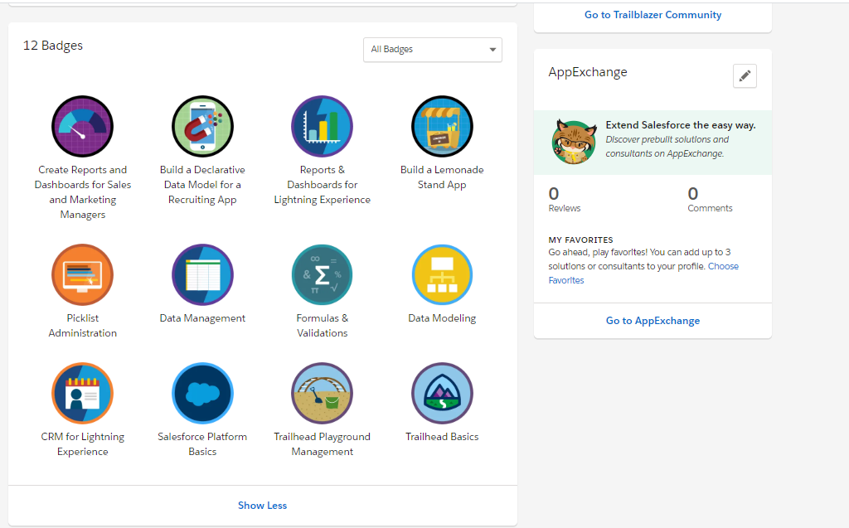

**6.STEP – The Hindu Group**

This course develops the key communication skills namely reading, writing, listening and speaking skills as well as grammar and vocabulary. These video lessons use contexts involving practical, real-life situations and equip learners will skills need for day-to-day communication. Skill up your communication with STEPATHON

Learning Modules

1. Reading

2 .Writing

3. Listening

4. Speaking

5. Grammar

6. Vocabulary

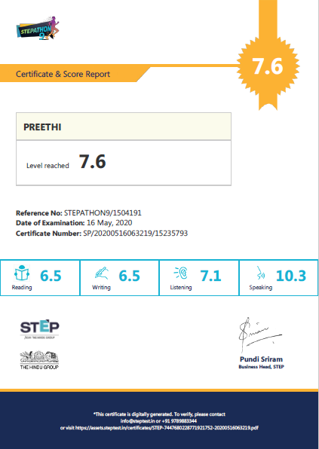

**7.VMware**

Businesses use virtualization to build large clouds to serve millions of people. Virtualization can be a powerful tool for anyone from public clouds to personal computers. You can use virtualization to run multiple operating systems on a single computer or backup your computer as a virtual machine. VMware IT Academy helps learners study cloud and virtualization.

Learning available from VMware IT Academy Courses

1. Software-Defined Storage Concepts -9 hours

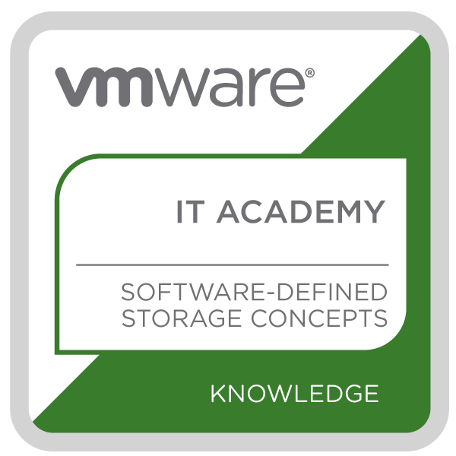

2. Network Virtualization Concepts- 9 hours

